|  |  |
| --- | --- |
| Real Time air pollution,Comparing continents and evaluating performance | Abstract  By reviewing live data of pollution indicators it will be shown which are the best and worst performers by continent. The data obtained can be expanded to include historical data to analyse long term performance. The snapshot provided can give an insight into where improvements could be targeted.  John Truong  Wei Ke (William)  Callum Linnegan  Karissa Malseed  James Rydlewski  Data Analytics Bootcamp: Project 1 |

# Introduction

Air Pollution is produced from a host of different sources and is closely linked to population size and heavy industries in a locality. This report is focussing on consideringa cross section of cities from different continents to make a comparison of the pollution data. From this it will be possible to glean which region is the greatest contributor to global air pollutants.

The data obtained is real time snap shot of air pollution in different cities this will be taken as a typical output for each of the cities and regions considered. For future iterations of this project historical data can be used which would show how air pollution has increased or decreased with respect to time.

# Data Presentation

The joy of data analytics is the story that can be presented illustrating the findings of the research performed. The data gathered for our analysis is real time air pollution data. The graphics elected to show this data are:

* Pie chart showing the concentration of pollutants in each regions worst performing city
* Bar chart showing the air quality index for each city within a region.
* Top 10 worst performing cities by region for each pollutant category
* Box and whisker showing the range of performance for each region for each pollutant type
* Scatter plot of pollutants vs location to see what correlation there is.
* Scatter plot of pollutants vs AQI to see what contributes most to AQI
* Google map to visualise the location and intensity of Air pollution.

# Background

This project is based on API calls for air quality data from the World Air Quality Index[1].

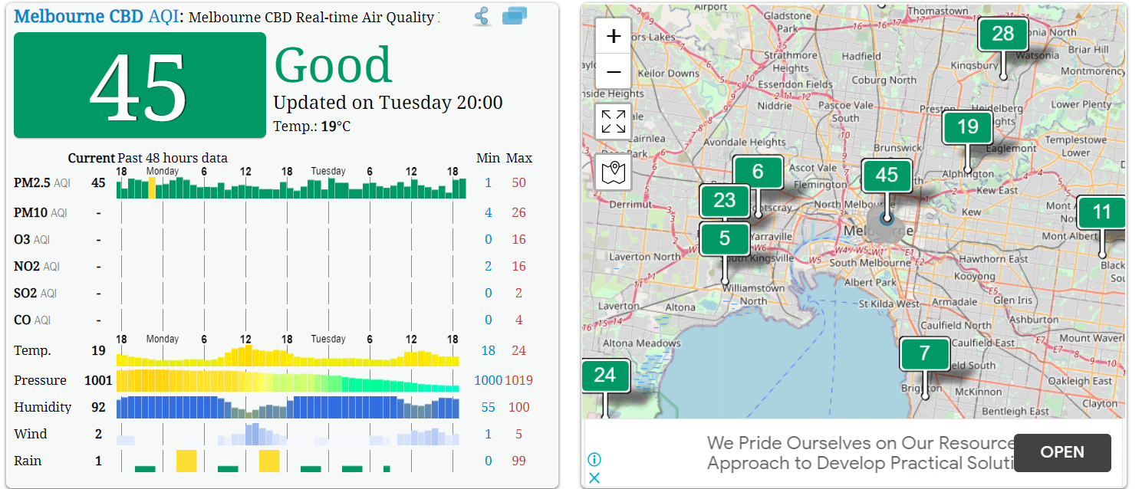

Figure 1 Sample of Data that can be obtained from WAQI

Figure 1 illustrates the sample data that will be explored in this analysis. Our objective is to obtain the following parameters for a number of cities across each continent.

|  |  |
| --- | --- |
| Parameter | Definition |
| PM 2.5 | PM 2.5 is particulate matter that is less than 2.5µm in diameter. These particles are small enough to be inhaled deeply which can have significant health implications. Often in regions where there is a high PM 2.5 count people will experience difficulty breathing. These particles are also problematic as they can be absorbed into your blood stream which can lead to further health complications of particular concern is cancer. |
| PM 10 | PM 10 is particulate matter that is less than 10µm in diameter. Although the particle size is greater than PM 2.5 it is still problematic. Typically found in smoke and smog in terms of air pollution but can also occur as suspended solids during the manufacturing process. An example would be rock dust whilst quarrying. In the context of air pollution. PM pollution causes significant health concerns. A particularly vicious episode occurred in London during the 1950’s which led to the death of over 4000 people. |
| O3 (Ozone) | Whilst Ozone occurring in the upper atmosphere has a beneficial effect for humanity as it shields the earth from harmful solar rays, at ground level it has the propensity to damage health. It is caused by the reaction of Nitrates and Volatile Organic Compounds (VOC’s) in the presence of sunlight. It is the main pollutant in “smog” and causes breathing difficulties for many. In addition to harming human health it can damage the wellbeing of plant life. Photosynthesis can be reduced slowing the plants growth and potentially killing affected species. As this happens there is less biodiversity which has a knock on effect to other entities dependent on the affected plant. |
| NO2 | Motor Vehicle exhaust gasses and heavy industry are responsible for the emission of NO2. The effects are breathing difficulties especially for the elderly and children. Significant quantities of aerosol NO2 can lead to acid rain which damages other elements of the eco system. Acid rain can further damage plant and marine life. |
| SO2 |  |
| CO |  |
| Air Quality Index (AQI) |  |

Coordinates

1. Website data obtained from is waqi.info. Wonderful resource with interactive map featuring air quality data from around the world.